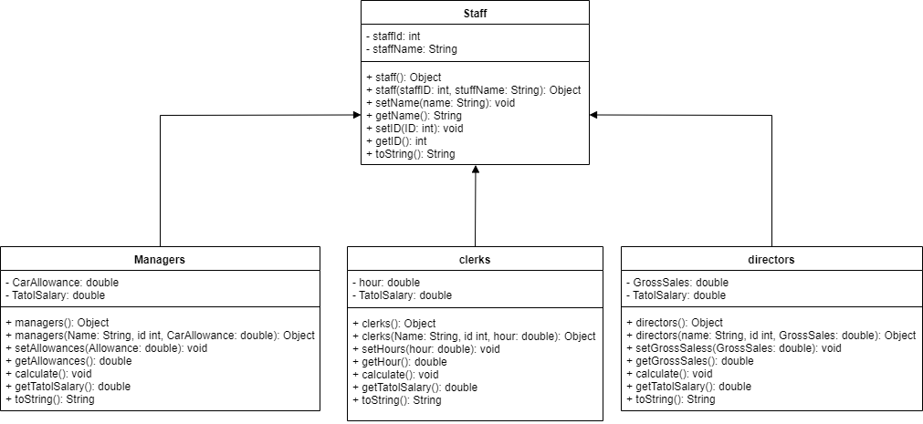

Name: William Gwee Jian Hui

Students ID: D190067A

Batch: IT-19A